MACH4METAL

Metalworking machinery
Transito 21,
6909 DA BABBERICH, Netherlands
Tel. + 31 (0)316 – 247123
Fax. + 31 (0)316 - 247956
info@mach4metal.com
www.mach4metal.com

Account No: 66.52.13.883
IBAN : NL33 INGB 0665 2138 83
BIC : INGBNL2A

HENNINGER centre grinding machine

- Make : Henninger Germany
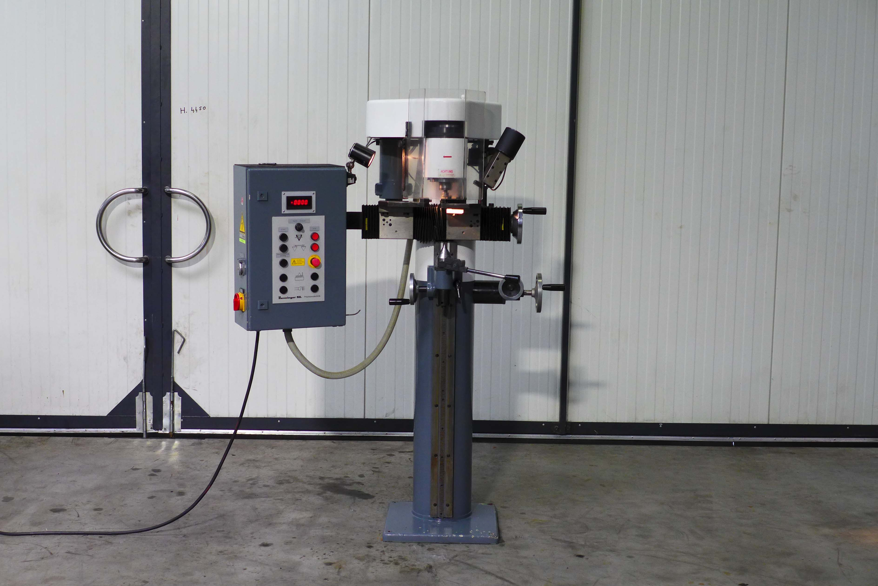
- Typ : ZS 150
- Mach.No : 96532
- Age : 1996

- Centre holes Ø Min : 2
- Centre holes Ø Max. : 85

- Length workpiece Min. : 200
- Length workpiece Max. : 1.200
- Workpice weight Kg : 145
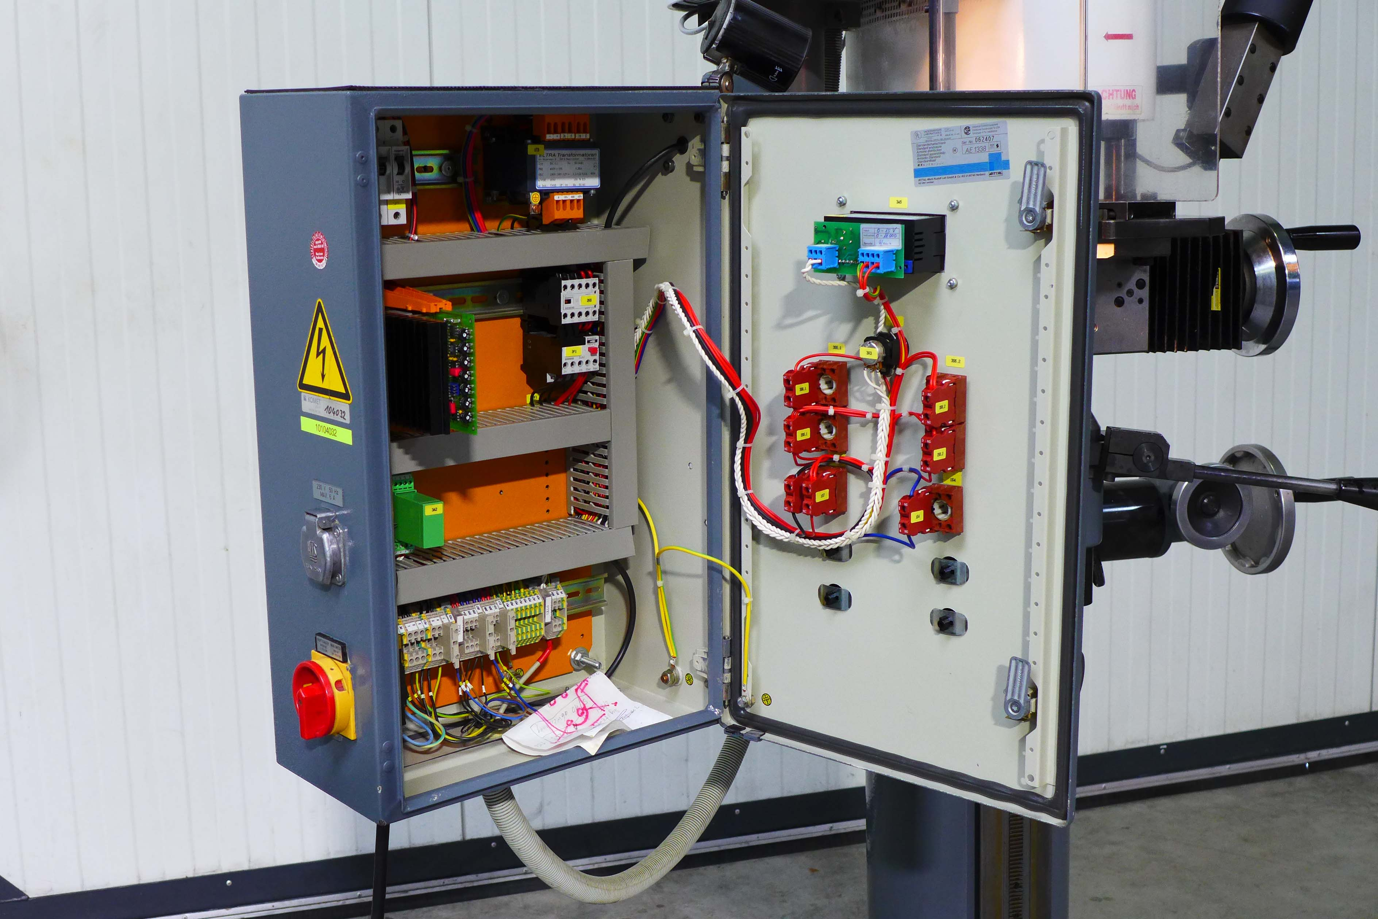

- Clamp range vice : Ø 5 - 105

- Grinding wheel spindle: Ø 50 x 250
- Collet mounting : Ø 1 to 8

- Grinding wheel head stroke : 150
- Dressing angle range : 60 - 90˚
- Eccentric rpm : 50 l/min
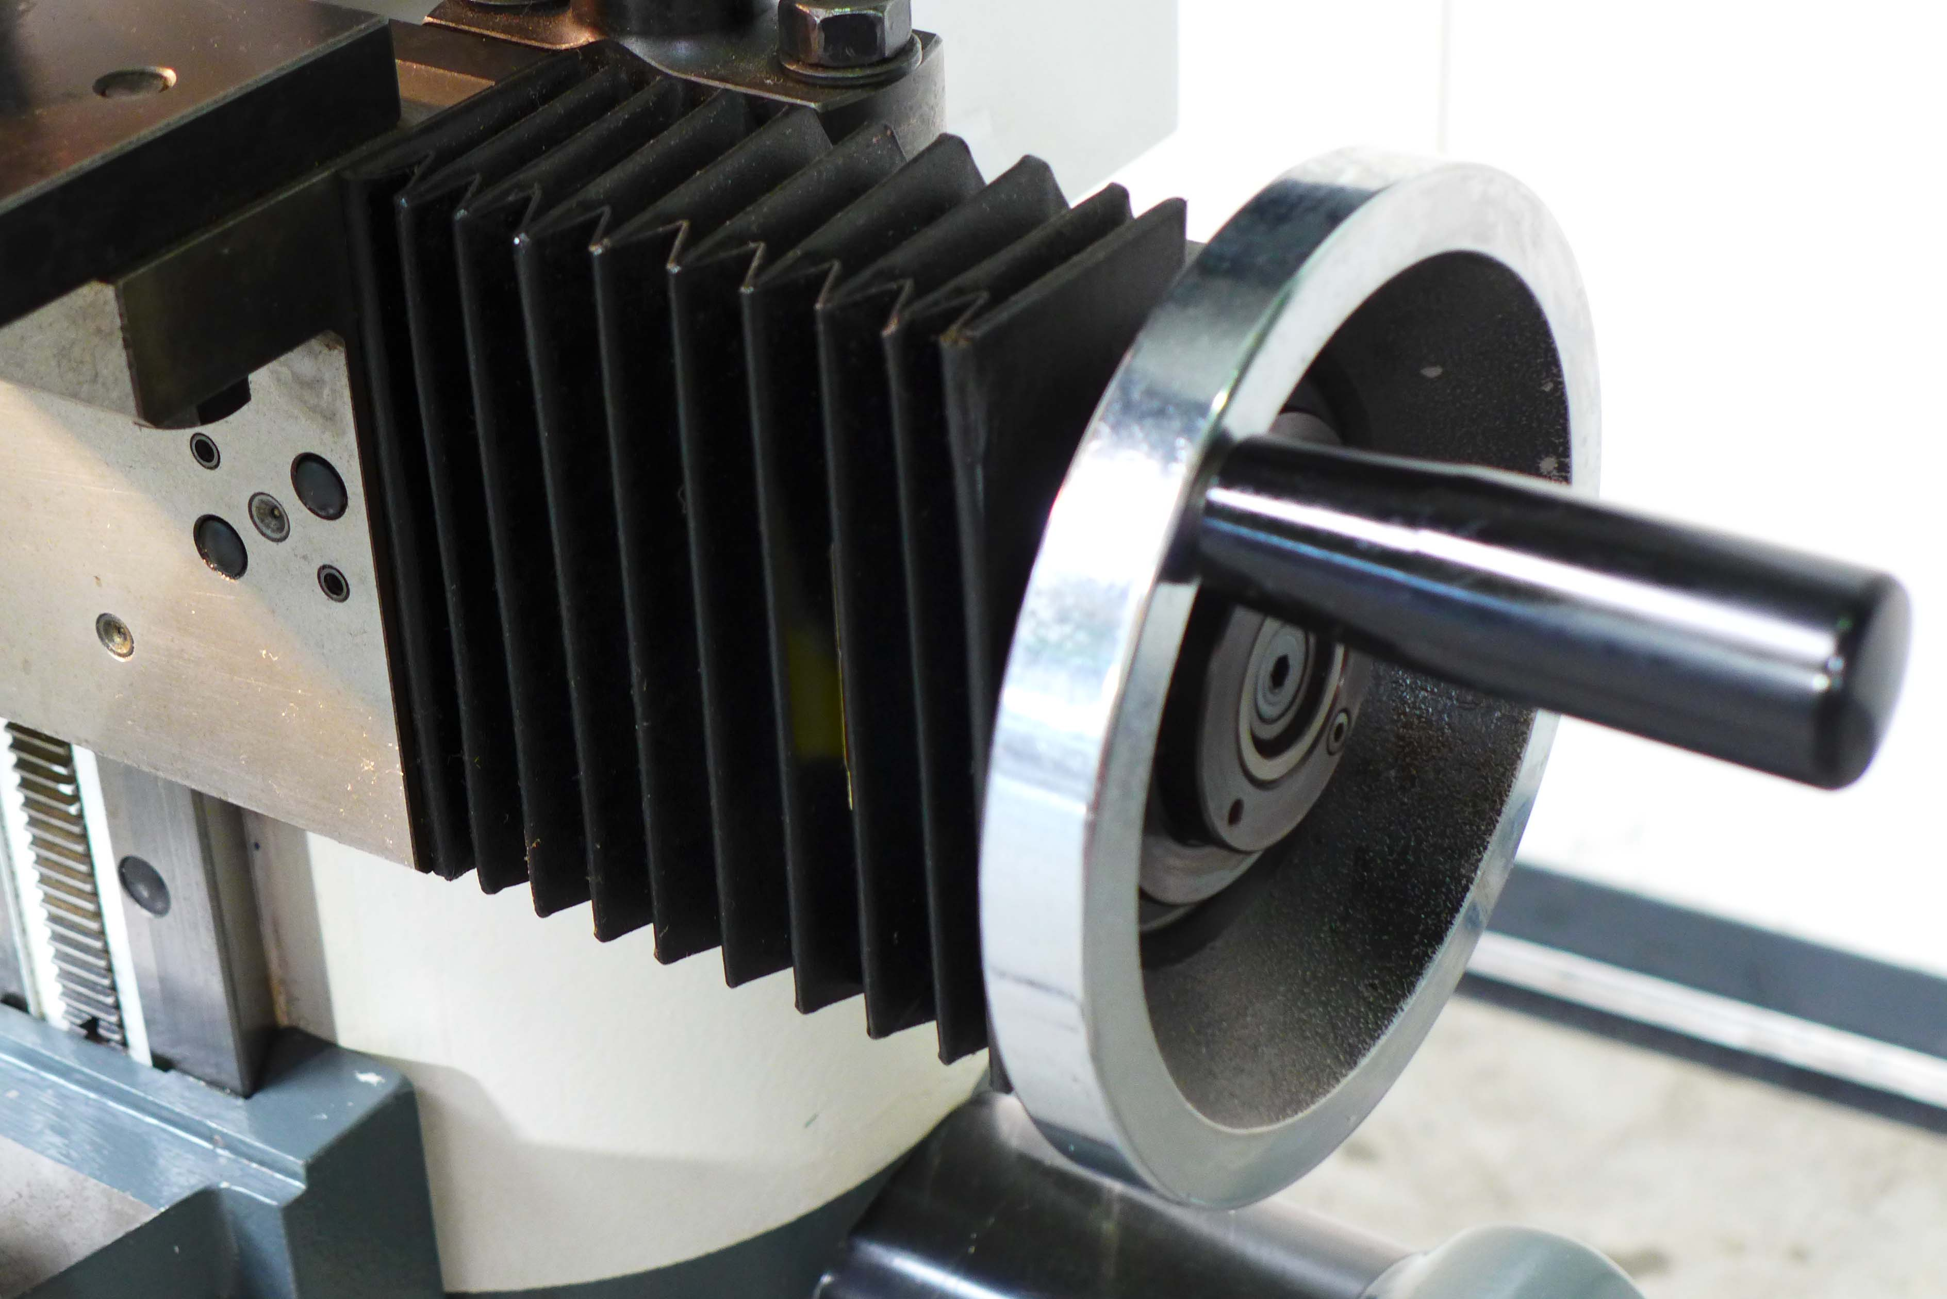

- Dimensions
- Length : 700
- Width : 1.100
- Height : 2.400
- Weight : 540 Kg

- Digital readout speeds
- New price EUR 40.000

Please Note: The above information has been obtained to the best of our ability and belief from, and from the manufacturers where possible. It is given in good faith, but its accuracy can not be guaranteed. Accordingly, it will not form a representation or constitute contractual terms. We advise you to check any vital details!

